## - Comments to understand the instructions/ commands.

Courier New Font – Commands to be entered in MSYS2 or information to be entered in configuration window

##HELICS installation - Building from Source - MSYS2 - updated

## Updating MSYS2

pacman -Syu

pacman -Syuu

pacman -Su

##Beginning HELICS build from source:

pacman -Sy base-devel mingw-w64-x86_64-toolchain git mingw-w64-x86_64-cmake mingw-w64-x86_64-boost mingw-w64-x86_64-qt6 mingw-w64-x86_64-zeromq

export PATH=$PATH:/mingw64/bin

cd /C

git clone https://github.com/GMLC-TDC/HELICS.git

cd HELICS

mkdir helics_build

cd helics_build

cmake-gui ../

##Click the Advanced check box next to the search bar. Then click Configure.

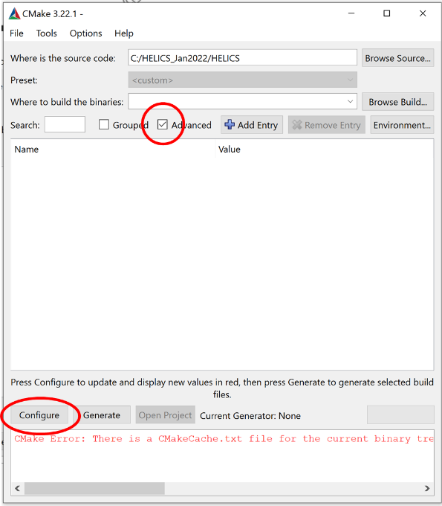

##A window will pop up asking you to specify the generator for this project. Select “MSYS Makefiles” from the dropdown menu. The native compilers can be used and will most likely default to gcc. The compilers can also be specified manually. Use the default native compilers option.

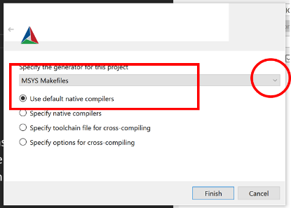

## Some variables should be set manually:

##CMake_INSTALL_PREFIX - set to C:/helics_install

##HELICS_BUILD_CXX_SHARED_LIB – enable (check box)

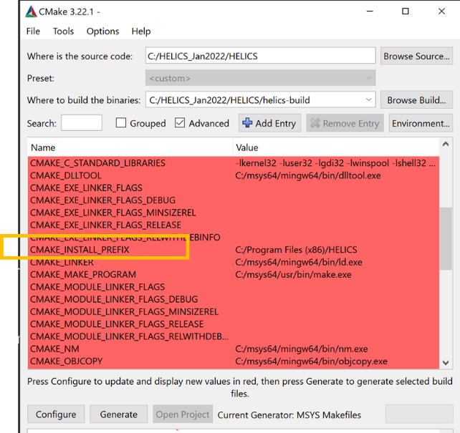

##Click on configure. Once configuration is done

##Click on generate

make -j

make install

##Add the following paths to the PATH environment variable as follows:

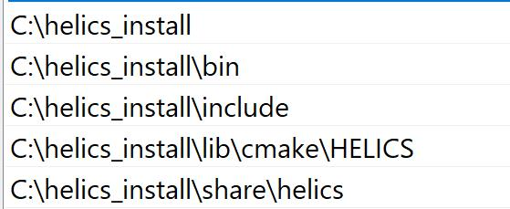

##Make sure C:\msys64\**mingw64\bin** is also added in the path

*****************************************************************************

##GridLAB-D Installation

##Start with fresh MSYS2 terminal after building HELICS and environment setup

pacman -S --needed base-devel mingw-w64-x86_64-toolchain git mingw-w64-x86_64-dlfcn mingw-w64-x86_64-xerces-c

export PATH=$PATH:/mingw64/bin

##Go to c drive

cd /c

mkdir GridLABD1279

cd GridLABD1279

git clone -b feature/1279 https://github.com/gridlab-d/gridlab-d

autoreconf -if

./configure --prefix=/C/gridlab-d/install64 --with-helics=/c/helics_install --with-xerces=/mingw64/lib --enable-silent-rules 'CFLAGS=-O2 -w' 'CXXFLAGS=-O2 -w' 'LDFLAGS=-O2 -w -L/mingw64/bin'

make

make install

##List environment variables

Path:



GLPATH



********************************************************************************

Install Python.

From windows command prompt, run the following:

pip install helics

From Python, verify helics installations by importing helics in python